ORGANIZATION OF EVENTS

Workshop materials | Version 2  5 2019

Table of Contents
Introduction 3
A. BASIC INFORMATION 4
1. Definition of an event 4
2. Organization of events step by step 6
B. EXTENDED VERSION 21
3. Application booking system 21
4. Website 22
5. Event's technical partners 25
6. Acquiring media patrons 25
7. Promotion (distribution of press releases, social media) 26
8. Press releases 29
9. Call center 30
10. Preparation and distribution of invitations (mailing, traditional invitations) 30
11. Welcome packs 31
12. Development of graphics 31
13. Sending organizational information to participants 32
14. Thanking 32
15. Reports 33
16. References 33
17. Organization of events on the Internet 33
18. Bibliography 40

Introduction
The organization of events has become very popular in recent years. Many years ago, we associated events mainly with concerts and sporting events. Today, the preparation of an event is part of a public relations strategy as one of the elements of a company's communication with its environment. An event also fits in with the characteristics of CSR activities, i.e. corporate social responsibility. This is the best way to communicate with the client. A well-organized event makes a person become attached to the brand, seeing it in a positive light. It can be assumed with a high degree of confidence that participation in a professionally prepared event will cause a client to come back to us. That is why it is so important that an event is related to a specific idea with which potential participants can identify.
It should be noted that the organization of an event is not just the domain of big brands. One can be tempted to say that anyone who wants to establish relations with their environment should be interested in the implementation of an event. This applies to both private and state enterprises, business support institutions, associations or cultural institutions. Building relationships is also important inside an organization. One of the ways of building them is to prepare meetings for integration and special occasions, for example at Christmas or Easter, as well as company anniversaries, and in the case of creators of culture, festivals, fairs or workshops.

BASIC INFORMATION
- Definition of an event
An event should be understood as a project fully planned and organized for a purpose. An event is an undertaking with a clearly defined time frame, and the actions for its implementation are complex and strongly interrelated. Most often it is implemented in a team, and its organization is aimed at achieving a desired result, e.g. to present a new product, to create a forum for the exchange of knowledge among people in a given industry. It can also be defined as a single program point or a series of points for a specific event forming a whole.
An event may take various forms, and its character will depend each time on the adopted goal and the specifics of the entity (client) for which it was prepared or the institution that is the initiator of the project. An event could therefore be a concert, a congress, and also the introduction of a product to the market, the so-called product launch, a demonstration, a meeting with an author or employee meetings for special occasions.
A distinguishing feature of the division of events may also be the criterion of the target groups to which they are addressed, e.g. film festivals, folk culture festivals, an art exhibition, or a handicraft or organic food fair. Events are also divided into those of mass and non-mass character. What we can consider a mass event is clearly defined by the provisions of the Act on the safety of mass events. According to them, a mass event is:
- an artistic entertainment event,
- a mass sports event (including a football match);
According to art. 3 point 2 of the Act, an artistic and entertainment event should be understood as an artistic, entertainment event or organized public viewing of television broadcast on screens or devices that enable the obtaining of an image with a diagonal of more than 3 m, which is to take place:
a) in a stadium, in another facility that is not a building or in a site that enables a mass event, where the number of places available to the public, determined in accordance with the provisions of construction law and fire protection regulations, is not less than 1000,
b) in a sports hall or other building enabling a mass event in which the number of places for persons provided by the organizer, determined in accordance with the provisions of construction law and fire protection regulations, is not less than 500;
A mass sporting event is an event aimed at sports competition or popularizing physical culture, organized at:
a) a stadium or in another facility that is not a building where the number of places available to the public provided by the organizer, determined in accordance with the provisions of construction law and fire protection regulations, is not less than 1000, and in the case of a sports hall or other building enabling a mass event - not less than 300,
b) a site enabling a mass event, where the number of places for persons made available by the organizer is not less than 1000.
In the case of European regulations, a mass event is characterized through the prism of the organization of football matches. The regulations are governed by Convention No. 120 on violence and excesses of spectators during sports events, in particular football matches.
Figure 1. Types of events
frequency
one-off
periodic
availability
paid open,
paid with limited access (by invitation)
free closed
free open
venue
open (outdoor events)
closed (in a building)
range of
influence
regional
national
international
purpose
social
cultural
sports
entertainment
religious
musical
educational
Source: own elaboration based on: Dariusz Tworzydło, "Practical PR"

One of the main goals of event organization is building and maintaining an image, which is why they are part of a public relations strategy. Regardless of whether an event is organized by an external company or an internal department of a given company, it must meet the same security standards and principles adopted in the implementation of such projects. It should be remembered that the need to create a positive image and the possibility to exist in the consciousness of the wider community in the local or national context also applies to the creators of culture. It is worth creators cooperating with local governments and local government cultural institutions. As a rule, these institutions have extensive experience in organizing various types of events and they have the necessary knowledge and contacts that can facilitate the preparation of an event. Local governments often organize their own cultural events. In this case, cooperation could consist of periodically taking part in them, e.g. as an exhibitor.
- Organization of events step by step
During the organization of an event, regardless of what kind it will be, it should be kept in mind that it is necessary to secure the execution of several elements that are necessary for proper preparation. In other words, these are activities that are the basis for organizing events. We will not be able to organize an event without them. Below is a summary of these activities.
  - Recognition
When organizing an event, regardless of whether it is a project commissioned by one of your clients or the head of the institution you are working in, or an independent initiative, you should start the task by conducting a detailed analysis, recognising the needs and expectations of the client or the environment for which you want to organize the event. Specify what the target group will be, i.e. who is to participate in the event, and analyse where the event should take place. It will also be necessary to determine the budget allocated for the organization of the event, because on the basis of that you will later be able to plan the distribution of individual expenses.
  - Concept
The first step in the organization of an event is based on the creation of a concept that will determine all the necessary assumptions of the event. It is important that this is well thought-out, consistent and tailored to the needs and expectations of the client or the communication strategy adopted within the organization. The same applies to the creators of culture who would like to prepare an event targeted, for example, toward the local community. In this case, it is necessary to determine what the characteristics of this community are and which forms of activity and entertainment they prefer, and to adapt the nature of the event to this group. In this case, it is worth taking into account the specificity of a region or a given town. If we want to promote cultural goods or regional traditions, we should consider how best to show them. For example, you can organize a show of folk costumes, an evening of poetry by local authors, a review of bands, etc. The concept should include several obligatory points the determination of which is indispensable when organizing any type of event.
During its creation, regardless of whether it will be a congress, conference, an outdoor event (an event in the fresh air, "in the open air"), a fair or handicraft workshops, one should remember about key elements of the document, such as:
Figure 2. Components of an event concept
  - The concept of the event should indicate its character and factors conditioning the legitimacy of the organization of the event.
Concept of the event
When describing the purpose of an event, you need to consider what effects you expect in the context of its organization. The goals must be measurable, for example, the organization of a two-day conference for 150 people. Happy Client
Purpose
The title of the event is of great importance to the aspect of promotion. First of all, the name of the event is what the recipients of the communication, our potential participants, associate it with. It is worth making sure that it is strongly correlated with the character of the event and the industry to which it is addressed.
Title / name of the event
Specifying the group of people to whom an event is addressed is important from the point of view of the promotion of the event, because promotional activities, information distribution channels, use of social media and the forms and content posted in them are planned in relation to the target group. They will be different in the case of organizing events for young people or people 50+, and different again for specialists in a given industry. The selection of the group also allows estimation of the number of applications, and thus the number of participants on a level that is satisfactory for the organizer. This number will be a reference point in subsequent activities related to reporting and billing of the event.
Target groups
This is one of the factors determining the success of the event. When choosing the date of the event, it should be analysed whether in the given period there are any events with a similar subject taking place, and whether the date indicated is not a day on which any national or religious holidays take place. In addition to the date, the duration of the event is also important. At the beginning it should be determined whether it will be one or a few days or whether it will last for three, five or more hours.
Timing
Often the participation of a given person in an event depends precisely on where it takes place. It is important that the venue (building) that we ultimately choose is tailored to our needs, offers the possibility of freely choosing the arrangement according to the concept we have adopted, and what is equally important - it suits the specific target group.
Lokalizacja
This is an important element from the point of view of event promotion. There are various distribution channels to consider when creating an event promotion strategy, in both traditional and social media. In the case of open events it is worth - if possible financially - planning an outdoor promotional campaign. You can learn more about media relations strategies here [link to the appropriate chapter].
Media relations

Exercise (120 min.)
- Decide what kind of event you want to organize.
- What elements should the concept include?
- Create a document based on the obligatory points.

  - Budget
The budget is made up of a document based on which all expenses related to the organization of an event are planned. As part of the calculations adopted in it, we can plan individual activities. If it is well prepared, it will allow you to easily control and, if necessary, adjust expenses at the stage of implementation of tasks related to the organization of the event. With its help, we can also determine the profitability of the event.
The first point in the budgeting process should be a discussion of its constituent parts. Therefore, sit with your team, analyse and work out all of the issues (tasks) that will be related to the incurrence of costs. Some of them (e.g. renting a room, plane tickets, accommodation) will be hard costs - those which we cannot avoid or manipulate. Each budget should be tailored to the given event, but there are elements that will be repeated in the cost estimate of most events. They are:
Figure 3. Elements of an event budget
1. Rental of a conference room/exhibition space
2. Creating and implementing a website or event on Facebook
3. Purchase of access to a ticket sale platform (system)
4. Speakers (travel costs, accommodation, appearance fee)
5. Compere/moderator of discussion panels
6. Promotion of the event
7. Accommodation
8. Catering
9. Audio equipment + sound system
10. Technical service
11. Translator (in the case of international events)
12. Promotional materials/gadgets
13. Artwork
Not all expenditures can be predicted, and the amounts we set up may change during the performance of individual activities. However, it would be an unacceptable move to completely omit this step and avoid making a cost estimate.

Exercise (30 min.)
- You already have the character of the event chosen and the concept developed
- Consider what hard costs you will incur in connection with the organization of the event
- Create a budget in Excel

  - Action plan
An operational plan is essential when organizing events. It systematizes our activities and allows them to be chronologically planned. The main document related to the action plan is the schedule, the preparation of which will protect us from failing to meet deadlines in the implementation of specific tasks.
Remember here about dividing tasks between members of your team and establishing the people who will supervise the degree of their implementation. Record these arrangements in the schedule. This will allow you to avoid chaos and disinformation. Tasks should be divided according to the key: before, during and after the event.

  - Confirmation of the date and rental of a conference room/exhibition space
Confirmation of the timing is a key task and should be one of the first things to be done. For events organized in hotels or conference facilities, information related to the following should be confirmed:
  - the capacity of conference rooms,
  - availability of exhibition space for sponsors and event partners,,
  - provision of food for guests by the hotel,
  - the type of technical equipment and technical support.

  - Obtaining permits for the organization of mass events
Open events, especially those of a mass character, such as festivals or family picnics, in which several hundred or more people take part, are governed by their own laws. To organize this type of event it is necessary to obtain a series of consents and fulfil the obligations resulting from the need to ensure safety, for which the organizer is responsible.
Remember that all consents and opinions are valid for 6 months from the date of issue! This date results from the provisions of Polish legislation. Therefore, it is important to remember that these regulations may differ from country to country. So before you start organizing an event in another one, read the necessary regulations!

Documents necessary to submit an application for a permit to organize mass events (concerns regulations resulting from the provisions of Polish law):
- Plan of the building (site) at which the mass event is to be conducted, along with its description
- Instructions on how to proceed in the event of a fire or other local emergency in the venue and during the mass event
- Scheduled timing of the mass event
- Information on the number of places at the mass event
- Information on anticipated threats to public safety and order
- Information about the organization of the security service and information service
- Data of the person designated as the manager of safety of the mass event
- Information on the method of ensuring the identification of persons taking part in the mass event
- Information about the image and sound recording devices installed
- Information on notification of the locally competent commander of the Border Guard unit
- Information on notification of the commander of the regional organizational unit of the Military Police
- Schedule of making the building or site available to the participants in the mass event
- Schedule for the participants in the mass event to leave the building or site
- Opinion of the district, regional or municipal police commander about the necessary size of forces and resources needed to secure the mass event, reservations about the technical condition of the building (site) and about anticipated threats
- Opinion of the district (city) commander of the State Fire Service about the necessary size of forces and resources needed to secure the mass event, reservations about the technical condition of the building (site) and about anticipated threats
- Opinion of the dispatcher of emergency medical teams about the necessary size of forces and resources needed to secure the mass event, reservations about the technical condition of the building (site) and about anticipated threats
- Opinion of the state sanitary inspector about the necessary size of forces and resources needed to secure the mass event, reservations about the technical condition of the building (site) and anticipated threats
- Program and rules of the mass event with information on how they will be made available to the participants in the mass event
- Regulations of the building (site), along with information on how they will be made available to the participants in the mass event
- Instruction specifying the tasks of the security service and information service
- Conditions of communication between entities involved in securing the mass event
- A statement on the equipment used to organise a football game
- Proof of payment of stamp duty
- Information on the location of the places and time at which alcoholic beverages will be sold, served or consumed at a mass event
- Power of attorney in administrative matters
  - Developing an event program
Regardless of whether you are organizing a conference for 100 people or a large open event for 1200 participants, each time you have to prepare an event program, set a timeframe in it and chronologically present all talks or activities/attractions. If necessary, divide it into appropriate blocks. In the case of conferences or training sessions, do not forget to include coffee breaks and lunch times. When developing an event agenda, you must plan the time of one talk. The recommended time is 30 minutes. Remember that the program should be adapted to the target group and the nature of the event itself.
It is worth ensuring that the agenda of an event, at least its working version, is ready when you start promotional activities. Make sure that the theme is distinguished from similar events. The more attractive a program you create, the greater the chance that it will encourage recipients to reserve a date in their calendar and attend the event.
Figure 4. Example of an event program
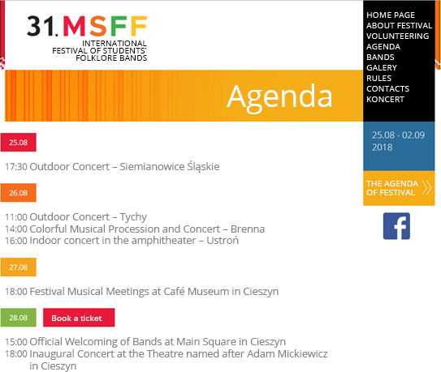
Source: http://msff.pl/program/

  - Acquiring speakers
In the case of conferences, congresses and training sessions, speakers will be your main marketing product. They attract participants, so it is worth ensuring that they are experts in their industry. The possibility of meeting the best specialists and authorities in a given field in one place does not happen often. Thanks to this, you can obtain a number of participants, and in the case of a ticketed event, increase ticket sales. In the case of events organized by the creators of culture – the people who can increase the interest in the event will be recognized artists (musicians, handicraft manufacturers, painters, film critics, etc.).
The costs you incur in connection with the participation of a potential speaker depend on the way you conduct negotiations with them. Most specialists value their skills and experience; however, you can offer them an appearance fee in place of the costs of flight/travel expenses accommodation and meals.
Remember - if you want to provide training materials, multimedia presentations to the participants of an event - you must have written permission from the authors.

  - Providing a compere/moderator
The compere - or the event host - has the greatest contact with the audience, he creates the first impression. You only get one chance to make a first impression, and the compere is responsible for ensuring that the start of an event is at least good. Contrary to appearances, conducting an event is not an easy task, so when searching for a compere or a moderator of a meeting (panel), you should pay attention to his experience. When choosing a moderator of an expert panel, it should be ensured that he is a specialist in the field that the panel will deal with. It is worth reserving time to check the candidate "in action" even on the basis of video recordings. The assessment should be made based on both diction, when a text is read from the page, and on showing creativity and knowing how to find and adapt to the situation that is happening at the moment on the stage. A good compere is characterized by the fact that his announcements are not dry information, available on the website, which the guests were able to find out at the stage of signing up for the event - on the contrary - he can narrate in an interesting, humorous way, create a positive atmosphere, and thus narrow the distance between the speakers and the participants of an event. In the case of open events, especially those in which children take part - flexibility and creativity of the host is even essential. The ability to encourage fun, invite participants to the stage, and have a short conversation with them, ensures that the event will be an invaluable added value for the organizer. No less important is the host's clothing, which must be adapted to the character of the event.

  - Acquiring sponsors and partners
Sponsoring an event is intended to bring benefits to both sides. The decision on financing an event is a business transaction for a given entity, used to a large extent to build an image, reach its target group (customers or contractors) or promote its product. For the organizer, acquiring a well-known brand or brands that decide to sponsor an event is important from the point of view of raising the prestige of the event. As a rule, significant companies do not get involved in, or sign on to, projects that they do not consider commendable.

Before you talk to a potential partner, you need to prepare a sponsorship package. At the beginning, develop a list of potential companies from which you would like to request sponsorship. Remember to analyse the nature of their activities and reflect on the benefits that can be gained by engaging in sponsoring the event you are organising. For this purpose, you can use the Crompton method called CEDAR EEE. It consists in determining the following values:
Figure 5. The Crompton method
Determination of the target group for the event.
Consumer audience - so-called audience profile
This is nothing but the estimated advertising equivalent based on the number of publications, advertisements and reports in the media and the time of their publication. Thanks to this, we can determine the value of the event and interest in the event, which is key information for the sponsor.
Exposure potencial (risk potential)
At this point, distribution channels and their recipient groups should be defined.
Distribution chanel audience (recipients of the distribution channel
Competitive advantages are defined here. It should be indicated whether the event is organized periodically and already has its own brand and reputation (if so, it is worth showing what benefits the previous sponsors have gained), whether it is being organized for the first time, and if so, what sets it apart from similar events. With reference to this point, the issue of so-called exclusive agreements can be considered. From the sponsor's point of view, this is a very lucrative entry in the offer.
Advantage over competitors
The organizer determines the amount of funds that the sponsor has to provide in connection with the involvement in financing the event. One solution, although less frequently used, is to propose cooperation on barter principles - at least in part of the activities.
Resource investment involvement required (contribution to investments)
At this point, the benefits for the sponsor should be specified in relation to the nature of the event, especially in the context of the impact of his involvement on brand image.
Event's characteristic (characteristics of the event)
This is the assessment of the organiser's credibility. It is worth presenting your experience. If it is an event that takes place periodically, provide such information.
Event organization’s reputation (reputation/perception of the event by the recipients)
Presentation of the exact number of tickets for the event dedicated to the sponsor, VIP tickets for accompanying events, the possibility of branding an exhibition area, festival area or VIP box with the sponsor's logo, arranging a meeting of the sponsor's representatives with the star of the evening, etc.
Entertainment and hospitality opportunities (attractions and the way of "taking care" of participants)
Source: own elaboration based on: http://www.cte.org.pl/pliki/Sponsoring%20imprez%20masowych.pdf

The final product of the analysis should be a sponsorship package that is the result of its application. The most important part of this document is to describe the benefits that the organizer can provide to the sponsor as part of the financing.
Benefits should be presented in terms of the slogans shown in the table (from the most important to the less significant) broken down into specific packages, both in terms of name and price, e.g. platinum, gold, silver, bronze standard. An extended, detailed description can be presented on the following pages of the package or developed as an insert for the document.
Figure 6. Example set of sponsorship benefits

 | GOLD | SILVER | BRONZE | STANDARD
 | 40,000zl | 30,000zl | 10,000zl | 5,000zl
title of partner | Main | Partner | Partner | Partner
Partner’s logo or name in press material | yes | yes | yes | yes
Partner’s logo on the home page | yes | yes | yes | yes
Partner’s logo on the website | yes | yes | yes | yes
giving the Partner’s name in the official part of the Congress | yes | yes | yes | yes
Partner’s logo in own publications | yes | yes | yes | yes
showing of commercial | yes | yes | yes | -
information about the Partner on social media | yes | yes | yes | -
insert with promotional materials | yes | yes | yes | -
Partner’s name or logo in mailing to participants | yes | yes | yes | -
Partner’s name or logo in mailing with organisational information | yes | yes | - | -
Partner’s name or logo in mailing with thanks | yes | yes | - | -
stand | yes | yes | - | -
possibility of appearing with a talk | yes | yes | - | -
organisation of a workshop | yes | - | - | -
organisation of a competition | yes | - | - | -
roll-up banners in the venue | 4 | 3 | 2 | 1
invitations to the Congress | 8 | 6 | 4 | 2
invitations to the evening event | 8 | 6 | 4 | 2
individual negotiation | yes | yes | - | -
The prices given are net prices

Source: own elaboration based on materials from Exacto Sp. z o.o.
  - Regulations
Regulations prepared for an event need to contain information about:
- The organizer of the event, his name and registration data,
- Time and place,
- Terms of participation, including the prices of tickets,
- Data for bank transfer - in the case of paid events,
- The course of the event,
- Safety rules,
- Principles of processing and protecting personal data of participants in accordance with the new regulations (GDPR),
- Principles for the awarding of prizes as part of competitions organized during the event.
An application form should be attached to the regulations.

  - Attractions
This is an aspect that is particularly important when organizing open events. When selecting them you have to take into account the nature of the event, the target group and customer expectations. When organizing folk festivals or handicrafts fairs, you should take care of the attractions for the participants, e.g.
- handicraft workshops,
- art exhibitions
- face painting,
- competitions, for example a recitation or artistic contest
- juggling show,
- amusement park,
- separation of the relaxation zone for adults,
- concert
In the case of conferences, when the program provides for an evening meeting or a gala, plan to make the evening special with attractions such as artistic performances, live concerts, cabaret shows, laser shows, etc.

  - Set design
The stage design of an event influences its reception. It is particularly important in the context of organizing festivals, carnivals or fairs. Try to make it unique, distinguished by its shape or visual elements.
The set design should be arranged according to a prepared plan, which will vary depending on the project. It would be good for the outline to be visualized, to be sure before setting the stage that our ideas do not conflict with reality. The design should include:
- the size of the stage,
- positioning of lighting, multimedia screens, as well as elements of visual advertising of sponsors in the form of banners, winders or pneumatic poles,
- protection of the sound system, including permanent access to electricity – in case of unforeseen power outages, power generators should be rented,
- designating a zone for technical maintenance and securing it from access by third parties,
- designation of the area for the reception/congress office,
- securing the backstage zone for the organizers,
- in the case of a seated event - setting of chairs and tables (theatre, school, horseshoe, cocktail party, banquet);

Figure 7. Types of table and chair settings in a conference/banquet room
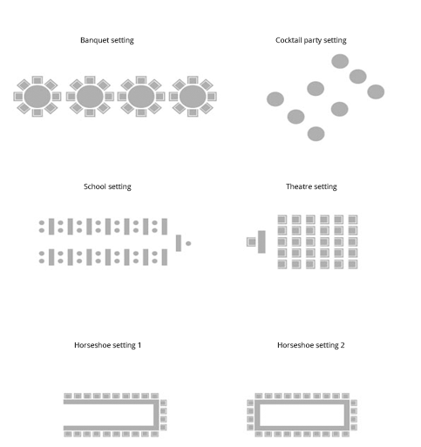
Source: own elaboration based on materials from Exacto Sp. z o.o.

  - Catering/menu selection
Remember to ensure that the menu is always properly matched to the nature of the event. Also ensure provision of vegetarian and vegan items. When organizing a small workshop or company meeting, try to determine whether its participants are not allergic to the individual components of the menu. It is a good solution is present a menu a few days before the event, so that the guests have time to familiarize themselves with it and choose the right items for themselves.
If you cannot use a hotel’s infrastructure, provide the service of a professional catering company. Remember, however, that you need to find out what the company provides as part of the order, and you should additionally ensure that guests do not leave an event hungry. The choice of the final menu is always linked to the price. When negotiating with a hotel or a catering company, you must have a fixed amount determined for one person. In the case of outdoor events, you should ensure constant access to water and electricity. Festivals are governed by their own laws and the most common type of food served at this type of events are grilled dishes, popcorn, cotton candy, etc. In the case of food fairs, their participants can take advantage of what the exhibitors prepare.
Remember to arrange places to eat, regardless of the type of event. Provide tables and chairs. They can also be wooden benches - these will work well in, for example, the case of folk culture festivals. Currently, there are many companies operating on the market providing services in the area of renting this type of equipment. If you are hiring a catering company, make sure that it will provide tables and chairs. At this point, it is worth thinking about securing the event in case of bad weather. Tents that can be additionally equipped with flooring will be the best. If you are organizing an open event in autumn, a good solution would be umbrella heaters, which not only give warmth, but also decorate the tent.

  - Reception/congress office/information point
Depending on the event, the place where you will welcome your guests will have a different name. It is at the reception of an event or an information point that guests and participants in an event will be able to register, receive welcome packs or seek help with the event. Make sure the organizers stand out from the rest of the event participants. This can be done using identifiers, wristbands or clothes (shirts or blouses) with the word "Organizer". Registration at the reception can be done using the traditional method - signing the attendance list, or electronically - scanning codes generated during registration for each participant - the second solution will work best in the case of mass events.

  - Technical Support
This is necessary in the organization of every event. It is responsible for the proper functioning of the sound system, lighting and display of images, animations and films.

  - Rehearsal
It is impossible to map one-to-one, but before an event run trials of sound and lighting, and play the commercials of sponsors and partners. If there are musicians during an event, it is necessary to plan the band's rehearsals, just like the compere. This is also a time when you can check if the space is arranged in accordance with the design.

  - Photo and video reports
Conducting photo and video reports of an event is of particular importance in carrying out promotion, so ask for professional photography and operator services. Keep your photos up to date on the social networks and website of an event. Video editing of an event is usually expected to take up to two or three weeks, but you can boast about the effects of work even a few weeks after an event. In this way, you will keep your interest and bring back pleasant memories for the participants.

  - Safety
The legal regulations described below concern Poland. Each time you organize events in your country, you must comply with the legal requirements applicable in that country.
Section 2 of the Act on Safety of Mass Events clearly defines the obligations incumbent on the organizer of an event. According to the provisions of the Act, they are:
- ensuring safety for people participating in the event;
- protecting public order;
- provision of medical services;
- ensuring the appropriate technical condition of buildings together with the technical installations and equipment serving them, in particular fire and sanitary facilities.
The organizer is also responsible for:
- meeting the requirements specified in construction law, sanitary regulations and fire protection regulations;
- securing the participation of security services, information services and a manager of these security services;
- provision of medical assistance;
- securing sanitary and hygiene facilities;
- designation of escape routes and roads enabling access to rescue and police vehicles;
- provision of conditions for organizing communication between entities involved in securing the mass event;
- provision of rescue and firefighting equipment and extinguishing agents necessary to secure the mass event in the scope of rescue and firefighting activities;
- separation of a room for the services managing the security of the mass event.

    - Security service
The number of security and information service personnel is defined as follows:
- in the case of a mass event that is not a massive risk event - at least 10 service members: security and information, for 300 people who may be present at the mass event, and at least one more member of the security service or information service for each extra 100 people; however, with not less than 20% of the total number of service members being members of the security service;
- in case of a massive risk event - at least 15 service members: security and information, for 200 people who may be present at the mass event, and at least 2 more members of the security or information service for each extra 100 people; however, with not less than 50% of the total number of service members being members of the security service.

  - Fairs, festivals, Ecogalas - how to exhibit at them
The organization of this kind of events takes place by means of specific procedures. If you are a creator of a handicraft, a food producer or a folk artist and you are only considering taking part in industry events where you want to organize a stand and advertise your products, you must adapt to the requirements of the organizer. It is worth remembering a few steps that will help you plan activities related to your participation in fairs or festivals.
- Preparation of a list of events based on reconnaissance of online conference calendars, e.g. CONFERENCE INFORMATION. It is also permissible to search for information by entering key words in a search engine, such as handicrafts fairs, food gala. The results should be saved in the form of a schedule of events (this can be created, for example, in Excel - an example schedule is shown in Figure 8)

Figure 8. An example schedule of industry events
Fairs and conferences in the airline industry |  | 1 | 2 | 3 | 4 | 5 | 6 | 7 | 8 | 9 | 10 | 11 | 12 | 13 | 14 | 15
October 2018
1 | ASA Meetings (Rzeszów)
2 | VIII Warsaw Days of Technology
3 | 100-years of aviation exhibition, Warsaw Polytechnic
4 | 9th International Materials, Technology and Composite Products Fair (KOMPOZYT-EXPO (Kraków)
5 | Aviation School Technical Conference (Warsaw)
November 2018
1 | Warsaw Industry Week
2 | 9th European Forum of Marketing of the Institute of Science and Research, Aviation Institute, Warsaw
3 | Graduate Talent Days
December 2018
 | no information
January 2019
1 | Conference ‘Fatigue in aviation construction’ (Warsaw)
February 2019
 | no information
March 2019
1 | Work Expo (Rzeszów)
2 | Edu Salon (Rzeszów)
3 | New generation aviation – strategies, technologies, solutions (Warsaw)
Legend: date of event

Source: own elaboration based on materials from Exacto Sp. z o.o.
- Contact with an event organizer in order to obtain information on the conditions of participation in an event as an exhibitor.
- Developing the concept of a stand arrangement, unless the rules are imposed in advance by the organizer of the event. If you are going to prepare a stand specially for a given occasion - make sure that the design will be ready in time.
Tip: when ordering and arranging the date of delivery of the finished product, plan a reserve from 7 to 14 days.
As a rule, the opportunity to prepare a stand as part of a fair or festival is additionally payable. In the regulations of an event the organizer determines the price that was established for renting the exhibition space. The regulations may make the possibility of organizing a stand at an event conditional on the order of submissions from exhibitors. Read the regulations and application forms carefully. The price of stall fees usually includes additional benefits, including: the possibility of selling products, the promotion of the exhibitor in all advertising activities carried out by the organizer, the use of sanitary facilities or security in the site and during the event. In the case of the sale of alcohol it is necessary to obtain a one-off permit for its sale and serving. Artists selling handicrafts can sell using cash registers or sales records, as well as a payment terminal. Increasingly, one of the additional proposals is the possibility of the exhibitor appearing with a short talk on the main stage or running a workshop. Be prepared for this eventuality. Think about how you can sell your product or service in an interesting way. Think about the form and content you share with the audience.

When preparing the arrangement of the stand, it should be adapted to the character of an event. Usually the regulations specify how the exhibitor can prepare his pavilion, arranging it in a way related to the tradition and the region from which the presented product comes. As an exhibitor, you may also be obliged to prepare a stand in accordance with the adopted stand design imposed by the organizer. The rules for the setting up of the stand before the event and dismantling it afterwards are also important (the organizer will determine the day/days and times in which it should be done).
You should also have information related to the technical equipment of the stand. Make sure you have constant access to electricity and water. Access to water is particularly important for exhibitors of food products. The organizer should provide access to taps with water and sinks (one for the sellers, the other for kitchen utensils), for exhibitors who bring with them food that is not hermetically packaged. It is a prerequisite for food sellers to have a valid sanitary record book.
The organizer can prepare special passes for exhibitors so that they can use zones designated only for them. Usually, exhibitors also have a separate entrance to an event site.

EXTENDED VERSION
The actions listed below belong to those that are considered optional, i.e. those whose lack of implementation will not significantly affect the organization of an event, especially in the case of events organized by the creators of culture.

- Application booking system
You have two options - using ready-made systems or dedicated online ticket sales platforms (for both paid and free events, e.g. Evenea) or creating and implementing your own system. In both cases, you will incur costs, which is why the final choice is always up to you.
When creating the form, think about what data is necessary for you to obtain in the registration process. In the case of free events, there is no need to collect data related to issuing invoices. The standard form should contain the following data:
- first name
- surname
- e-mail address
- telephone number (you can divide between mobile phone and landline or allow the appropriate number to be entered in one field – when deciding on the second solution (while creating an electronic form) make sure that this is possible from the programming side.
- the name of the institution
- position occupied
- place i.e. province / region / city

You can mark data that is obligatory using an asterisk. The electronic form should be programmed in such a way that failure to fill in an obligatory field would result in blocking the transition to the next step, and incorrectly completed spaces should be highlighted in red.
Regardless of which registration method you choose, remember to ensure that the data acquisition system complies with the new regulations on personal data protection (GDPR). The form should be designed so that the person subscribing to an event agrees to the processing of personal data, including their processing for marketing purposes, transfer of commercial information and the use of telecommunications terminal equipment (telephone, mail) for the purpose of direct marketing. To facilitate the collection of consents (especially with the help of an electronic form), a selection button known as a checkbox should be created. As in the case of filling in data fields, a failure to select a button that you specify as obligatory should block the transition to the next step.
The form will be useful in the case of conferences, training sessions, etc. If, as a creator of culture, you want to run a periodic workshop, for example in handicrafts, it is worth using an electronic form that easily organizes the list of participants.

- Website
The website is one of the basic elements of the promotion of an event, especially conferences, festivals and congresses. It is important that it is consistent with the visual identification adopted for the needs of an event organization. Most often, the creation of a website is entrusted to a professional IT company. Nevertheless, there are content management systems that we can use when running a website without specialized programming and IT knowledge.
The website should be launched before promotional activities start or at the latest at the same time. Remember to have at least the basic content such as information about the time and place of an event at the start. If possible, include a working version of the program and news about planned attractions, art performances, workshops or competitions. If you are organizing a conference or training session - post the names of the speakers, moderators or hosts.
In the case of the creators of culture, who often work with local governments or cultural institutions in the organization of events, it is worth ensuring that the website we have created is promoted through a partner, such as the City Hall. Often, authorities keep a calendar of events on their websites. This is a good way to promote your event. In this way, we have the opportunity to increase the reach of the number of people who will learn about our initiative. The institutions are very likely to agree, especially if they are also a partner/sponsor of the event.
In order for the site to be clear and legible for the recipient, the content should be divided into dedicated tabs. As the site expands, there will be more and more of them, but the basic ones are news, program, regulations and contact. It is necessary to create a button that links directly to the registration form. It is also a good idea to put a map with the location of the venue and directions on how to get there. The site should also include links to social profiles dedicated to an event. Most website templates have already programmed social media icons, which should be activated by linking a specific profile.
[Responsiveness - the key word in creating a website. A responsive site is one that adapts to the size of the screen on which it is viewed].

Figure 9. The Crompton method
Determination of the target group for the event.
Consumer audience - so-called audience profile
This is nothing but the estimated advertising equivalent based on the number of publications, advertisements and reports in the media and the time of their publication. Thanks to this, we can determine the value of the event and interest in the event, which is key information for the sponsor.
Exposure potential
At this point, distribution channels and their recipient groups should be defined.
Distribution channel audience
Competitive advantages are defined here. It should be indicated whether the event is organized periodically and already has its own brand and reputation (if so, it is worth showing what benefits the previous sponsors have gained), whether it is being organized for the first time, and if so, what sets it apart from similar events. With reference to this point, the issue of so-called exclusive agreements can be considered. From the sponsor's point of view, this is a very lucrative entry in the offer.
Advantage over competitors
The organizer determines the amount of funds that the sponsor has to provide in connection with the involvement in financing the event. One solution, although less frequently used, is to propose cooperation on barter principles - at least in part of the activities.
Resource investment involvement required
At this point, the benefits for the sponsor should be specified in relation to the nature of the event, especially in the context of the impact of his involvement on brand image.
Event's characteristic
This is the assessment of the organiser's credibility. It is worth presenting your experience. If it is an event that takes place periodically, provide such information.
Event organization’s reputation
Presentation of the exact number of tickets for the event dedicated to the sponsor, VIP tickets for accompanying events, the possibility of branding an exhibition area, festival area or VIP box with the sponsor's logo, arranging a meeting of the sponsor's representatives with the star of the evening, etc.
Entertainment and hospitality opportunities
Source: own elaboration based on: http://www.cte.org.pl/pliki/Sponsoring%20imprez%20masowych.pdf

The final product of the analysis should be a sponsorship package that is the result of its application. The most important part of this document is to describe the benefits that the organizer can provide to the sponsor as part of the financing.
Tip: Benefits should be presented in terms of the slogans shown in the table (from the most important to the less significant) broken down into specific packages, both in terms of name and price, e.g. platinum, gold, silver, bronze standard. An extended, detailed description can be presented on the following pages of the package or developed as an insert for the document.

Figure 10. An example set of sponsorship benefits

 | GOLD | SILVER | BRONZE | STANDARD
 | 40,000zl | 30,000zl | 10,000zl | 5,000zl
title of partner | Main | Partner | Partner | Partner
Partner’s logo or name in press material | yes | yes | yes | yes
Partner’s logo on the home page | yes | yes | yes | yes
Partner’s logo on the website | yes | yes | yes | yes
giving the Partner’s name in the official part of the Congress | yes | yes | yes | yes
Partner’s logo in own publications | yes | yes | yes | yes
showing of commercial | yes | yes | yes | -
information about the Partner on social media | yes | yes | yes | -
insert with promotional materials | yes | yes | yes | -
Partner’s name or logo in mailing to participants | yes | yes | yes | -
Partner’s name or logo in mailing with organisational information | yes | yes | - | -
Partner’s name or logo in mailing with thanks | yes | yes | - | -
stand | yes | yes | - | -
possibility of appearing with a talk | yes | yes | - | -
organisation of a workshop | yes | - | - | -
organisation of a competition | yes | - | - | -
roll-up banners in the venue | 4 | 3 | 2 | 1
invitations to the Congress | 8 | 6 | 4 | 2
invitations to the evening event | 8 | 6 | 4 | 2
individual negotiation | yes | yes | - | -
The prices given are net prices
Source: own elaboration based on materials from Exacto Sp. z o.o.

- Event's technical partners
At present, the standard for the organization of events is cooperation with companies providing various types of technological and technical solutions, such as participant registration systems, ticket purchasing, stage design or sound systems. The starting point for talks with potential partners should be an offer of cooperation. It can be prepared based on the package that you develop for sponsors. Another way of establishing cooperation is cooperation on barter principles. A barter agreement is characterized by the exchange of services for services, goods for goods, goods for services or services for goods. Mutual benefits must be equivalent to each other. It is an innominate contract, i.e. it has not been defined by a legal definition, but it is in the nature of a paid contract.

- Acquiring media patrons
Media patrons are very important from the point of view of event promotion. They generate the majority of publications about an event. It is worth trying to ensure that patronage of an event covers industry, national and local media. The operation of the media patron is to strengthen the promotion and hence the sale of tickets, so think about what titles are the most important in terms of the ability to reach the target group. Remember that sometimes less means more, which is why it is worth focusing on obtaining three or four titles from each media group. Rely on quality, not quantity. You will get more benefits from publications in large, widely read media that guarantee to reach a large number of recipients.
Before you distribute invitations to become media patrons, do full research into the media with which you want to collaborate. Find out whether the profile of a given medium matches the nature of your event, then prepare a contact database. The standard in most media is to assign a specific contact person regarding media patrons or provide a dedicated e-mail address. This action simplifies work and shortens the waiting time for feedback. If there is no information on the website as to which address you should send an invitation to become a patron, the best solution is to contact them by phone and obtain an e-mail address. Thanks to that we are sure that our inquiry will get into the right hands. It often happens that the recipient of our message is the wrong person, or the e-mail address is not correct and is assigned to another editorial office (this situation usually applies to large publishers, to which several or more than a dozen titles belong). Try to avoid such situations, so you will not waste your precious time on several attempts at contact, which in the end will prove to be pointless.
When applying for media patronage, develop a so-called media package that will present mutual benefits on the part of the organizer of an event and the patron. The offer must be well thought out, adapted to the requirements of a given medium and contain proposals that you as an organizer will be able to implement (e.g. placing a logo on an event website, in your own publications, displaying banners or roll-ups at the venue, creating an entertainment zone together with the media patron during an event). Specify what actions you expect from the patron equally clearly, in particular, specify the number of press releases. It is recommended to publish at least three of them (the first - announcing an event, the second - describing the program and the third - summarizing). Other activities may include: video and photo reports, publication of interviews with the organizers, speakers or special guests at an event.
Tip: The media package does not have to comprise of several pages, which will come to nothing. It is important that it includes the necessary components such as: a description of the event, mutual benefits and details of the contact person. It is recommended to prepare the offer in a layout developed in accordance with the event identification. Pay attention to the size and type of the font. Choose the one that is the most readable. The most important information in the text can be bolded or highlighted in a different colour. Check the document for any spelling or stylistic errors. It is recommended to save the finished file in PDF format. In addition, the document should also be clearly described so that the recipient can easily read what is in it, as is the case with the title of the e-mail.

- Promotion (distribution of press releases, social media)
Promotion of an event should take place in several channels simultaneously and be consistent. All tasks regardless of distribution channels must be planned and included in an event schedule.
When deciding on activities in social media, they should be matched to the target group and it is necessary to reflect on which portals (Facebook, Instagram, Twitter, etc.) will be the best channel to reach the target group. It is an erroneous assumption that through social media we can only communicate with young people. According to recent data, over half a million Poles over the age of 65 use Facebook, while the entire community of this platform is over 16 million.
For comparison, the number of Instagram users in Poland is over 6 million and is constantly growing. According to the latest data, in 2018 half of the population of Europe used Facebook. The number of recipients who can be reached with a message at the same time is so large that giving up this method of communication with a potential participant would be a major negligence.
Data on users of Facebook and Instagram portals divided into women and men with a comparison of growth in relation to the months of September – November 2018 is shown below.

Figure 11. Summary of Facebook users
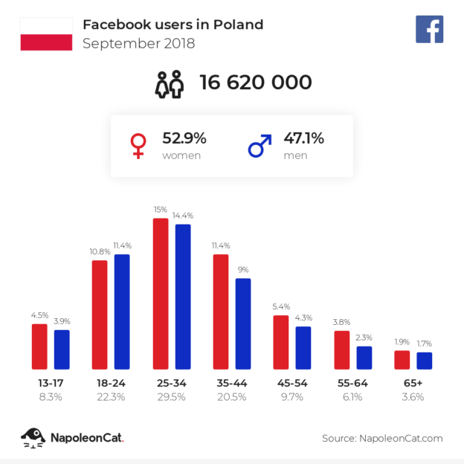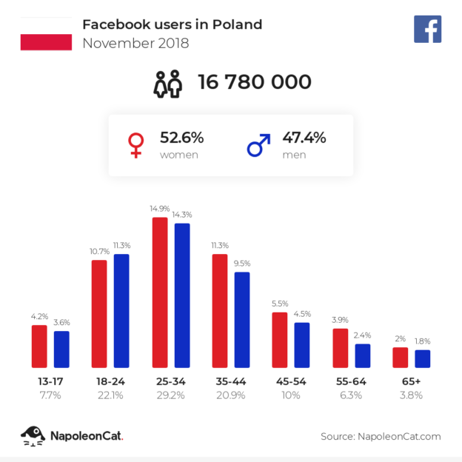

Figure 12. Summary of Instagram users

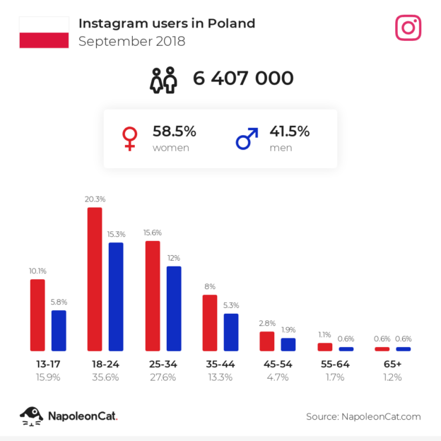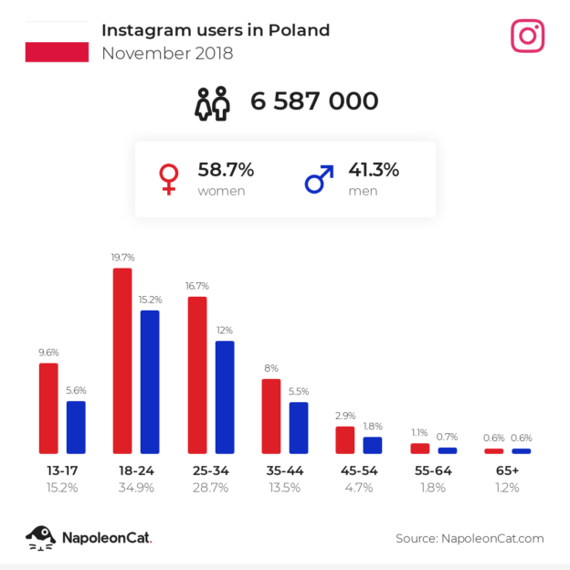
Source: https://napoleoncat.com/blog/polscy-uzytkownicy-social-media-na-koniec-2018-messenger-i-instagram-rosna-szybciej-niz-facebook/
Figure 10. Facebook users in Europe
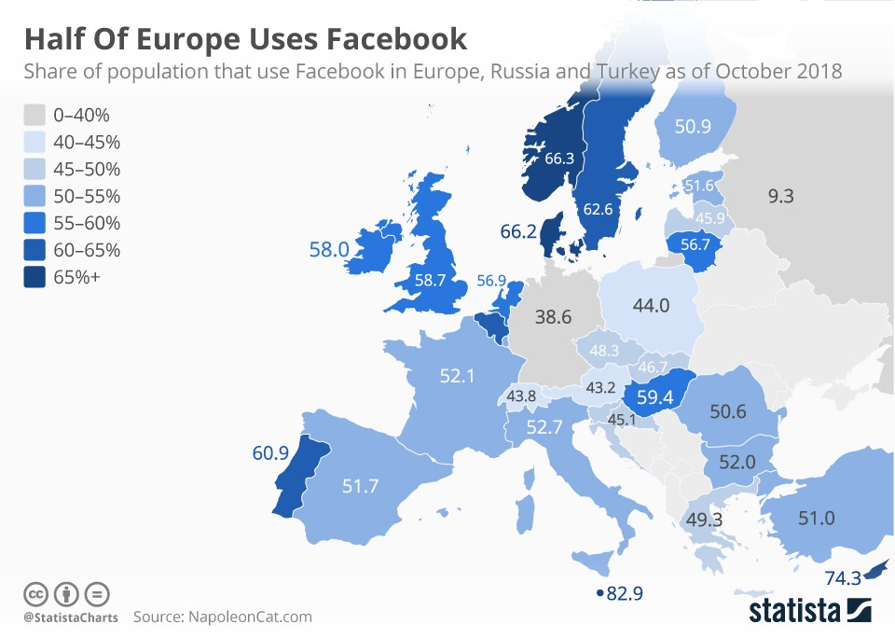
Source: https://mobirank.pl/2018/12/04/polowa-europy-korzysta-juz-z-facebooka/

Figure 13. Essential promotional activities in social media

Determine which portal your target group uses most often.
For periodic events, create a Fanpage, and for a one-time event, create an Event.
Develop graphic identification, used in creating content in all media.
Create a hashtag dedicated to the event, also use universal hashtags.
If the event has been organized earlier - present reports on its course.
Periodically place posts about speakers, the event program and attractions. It would also be good to publish behind-the-scenes content.
Promote the most valuable content, preferably those posts that have received the most likes and views, and thus strengthen your reach even more.
Engage people who follow your profile, e.g. using a survey.
Post videos. In the case of cultural institutions, these may be statements from the exhibition's patron, the director of the show, etc. These people are worth showing in their natural environment, which will strengthen the message.
Increase your media activity two weeks before the event.
During the event, place posts marked with hashtags with photos, quotes from speeches or prepare a live report. Check participants' reactions and respond to comments.
After the event, publish a photo gallery and prepare a summarizing infographic. You can ask event participants to rate it in a survey.

Source: own elaboration based on: https://www.slideshare.net/bartlomiejrak/social-mediowa-checklista-przed-eventem

- Press releases
Our creation of information in the context of events is an important element of promotion, above all, thanks to the fact that we can decide on the content of a press release ourselves. The information may take the form of an expert article or a purely informational article. Remember to include in each communication a message about the time and place of the upcoming event and how to register. The standard is to put links to the website and its individual tabs - especially to the one in which the application form is located. If the sponsorship or media package envisaged inclusion of information about the sponsor or patron, then do not forget to complete this task as agreed in the press release.
Both the number and frequency of press releases sent to the media should be included in the schedule. Each time a press release is distributed, follow up is required. Constantly monitor the media by conducting a quantitative analysis of emerging publications about an event. In this way you will be able to check how the media patron is fulfilling his commitments.

- Call centre
One of the most effective forms of event promotion, especially in relation to conferences, is direct promotion using a call centre. These activities are time-consuming and generate the most costs, but it is worth investing in them. The first step you need to do is to prepare databases that will be used in the so-called "call list". Preparation of such a database by the team will take many hours, therefore it is a better solution to use the services of companies that offer B2B or B2C databases.
Remember that the call centre tasks should be entrusted to an open and communicative person. It becomes the showcase of an event, which is why it is so important to have all the necessary information about it. He must know the time and place of the event, the main theme, ticket prices, program and website address. All of this information together with instructions for dealing with a difficult interlocutor should be included in the so-called conversation script. This document will facilitate the work of the marketer and ensure that fewer things surprise him during a conversation.

- Preparation and distribution of invitations (mailing, traditional invitations)

Mailing
Mailing is a relatively inexpensive but effective form of promotion and directly reaching a target group. It is a very personal method of communication. The ease of distribution of information and the possibility of getting quick feedback regarding interest in an event is another argument in favour of implementing this form of promotion. When creating mailing you can use the services of a professional company or implement it in a traditional way with the help of your mailbox.
The first obligatory step before delivery is to create a database with e-mail addresses along with the consent for sending marketing messages. These addresses can be obtained by direct telephone conversation as part of the call centre activities or later - during an event.

Invitations
Invitations distributed via the traditional route will work for conferences and congresses. The preparation of a mailing list and the use of mail merge in the addressing of envelopes is a facilitation in the preparation of mailing letters. The invitation should be consistent with the accepted identification at the graphic layer. If you decide to send traditional invitations, include in the budget the costs associated with printing them, the costs of envelopes and postal operator fees. You can print the invitations on your own or order a professional printing service. The second solution is especially recommended in a case where the designed invitation refers to a gala/business or holiday meeting - they are then printed on special high-quality paper in various non-standard formats.

- Welcome packs
Welcome packs are prepared for the participants of an event. Usually, they are handed out in bags marked with the event logo and promotional materials of sponsors and partners are placed in them. Participants receive them during registration at the congress or conference office. In the case of the creators of culture, it is a good idea for the preparation of this type of packs to design unique products, most related to the theme of the event, ideally handicrafts that will be handed to each guest at the entrance or handed out in a special, marked point.

- Development of graphics
The graphics designed for an event's needs should be:
- consistent presentation templates for speakers,
- identifier design – they should include their first and last name as well as their company’s name. For the organizers and speakers, add annotation about their function during the event. A different identifier design can be prepared for the organizers. In a case where in a single event, e.g. a conference or training session, there are several smaller ones, or the organizer of an open event has created dedicated zones and wants to clearly distinguish the participants, it would be good to prepare identifiers in different colours. Another way to distinguish guests is to equip them with bands in specific colours (according to zones). Remember here to provide the hosts with information about what the colours mean, how to get to the appropriate zone, what is provided to the participant of the event. This is important in the context of events where the ticket price was different depending on the package of benefits/attractions,
- an information board presenting the sponsors of the event,
- signage of zones, workshop and conference rooms,
- blank – a desktop background that will be set up on all multimedia carriers;
Figure 14. An example congress graphic.
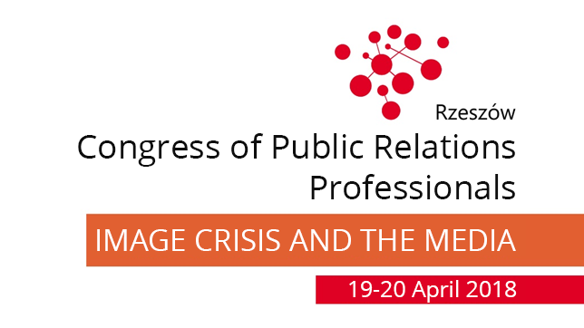
Source: own elaboration based on materials from Exacto Sp. z o.o.

- Sending organizational information to participants
This task is obligatory to perform primarily in the case of conferences, workshops or training sessions. Organizational information should be sent 2-3 days before an event. The message should include the time and place of the event, information about parking, the Wi-fi network, the event's office or the dedicated contact person regarding the signing of business trip expense claims. It is also worth adding a ‘how to get there’ map along with GPS coordinate data.

- Thanking
The standard is now to send thanks to participants and speakers after an event and encourage them to participate in the next edition (if you plan to do so). For training and conferences, include training materials in the thank-you message. As a rule, there are so many of them that it is not possible to send them as a traditional attachment in an e-mail. The solution is to place a link to a page where the participant will be able to download the materials. It is worth additionally protecting access to the materials with a password (especially if the speakers did not agree to share them with third parties - other than the participants of the event), which you provide in the e-mail. If you have organized a large mass event, you can record thanks in the form of a video and make it available on the social media profiles and the event website.

- Reports
You prepare them primarily for the sponsors and partners of an event, presenting in them the implementation of the benefits and obligations included in the contract. The settlement of contracts depends on the presentation of a report to the sponsor. The document must specify measurable results, the number of guests, statistics on the website and social networking sites, users' activity, number of information publications on an event divided into quantitative and qualitative effects and in what amount it has translated into an advertising equivalent, as well as the manner of implementing obligations resulting from the contract.

- References
The subcontractors that you have worked with will ask for them. You can also apply for references as an event organizer if you have organized them on behalf of or in cooperation with another entity. The document is made up of recommendations as to the quality of the tasks (a detailed description) carried out within the framework of an event.

- Organization of events on the Internet
  - Why is it worth doing?
Today, when almost all of us use the internet - according to data in 2017 in Poland, 95% of enterprises and 78% of households had access to the network - organization, or more precisely transmission, of event in the network gives us the opportunity to reach a wide audience.
There are several ways to provide reports from an event on the Internet. Large brands have their own platforms, through which they can transmit with the help of a staff of people: director, operators and sound engineers. However, the development of technology has given us great opportunities and we can ourselves implement live transmission - in other words live streaming, that is, transferring video content in real time, using the available tools, e.g.:
- Periscope - an application from the creators of Twitter. You can use it to share video only with people you invite to view it or all Twitter users who follow your profile. In the second case, our observers will receive a notification about our transmission. After its completion, we can save it in the application and allow it to be watched at a later time using the replay function.
- Meerkat - as in the case of the Periscope application, to be able to use Meerkat, it is necessary to set up a Twitter profile. Meerkat has additional functionalities, i.e. the ability to interact with recipients using embedded chat and real-time commenting.
- Facebook Live Video - live broadcasts on the most popular social networking site can be run by anyone who has an account on it. The video can be continually commented on.
- YouTube - People with an account and channel on YouTube can run Live video on the site. Transmissions can be carried out in 360º format. The chat feature is equally important, thanks to which we have the possibility of constant contact with viewers.
- Google Hangouts - the app allows live video to be delivered to Google+ account users. Live video can be transmitted as public or private. Thanks to the application, we can also make it available on our website. In addition, video streamed via Google Hangouts is automatically recorded and published on the YouTube channel.

  - Live video on Facebook
The implementation of live broadcasts on Facebook is relatively simple. The portal allows for live coverage via a fanpage, the use of OBS (Open Broadcaster Software) or Facebook API.
Live broadcasting using a fanpage is the most popular, mainly due to easy access to the tool. Below we present preparation of live broadcasting step by step:
- Turn on the fanpage and look for the PUBLISHING TOOLS tab

- Click on the film library in the list on the left side of the panel.

- Click on the LIVE button

- After clicking the live button, a new window will open with three tabs: post, settings and interaction, in which the place of transmission is determined, it is given a title and described using markers, and the form of transmission is selected. In the POST tab, specify the place of transmission using the drop-down list (marked with an arrow) and select the fanpage through which you want to transmit.
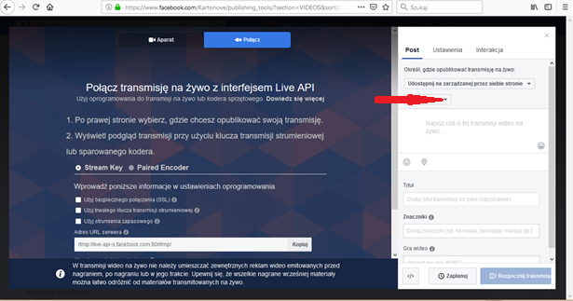
- Write a few sentences about the transmission in the white box below the drop-down list.
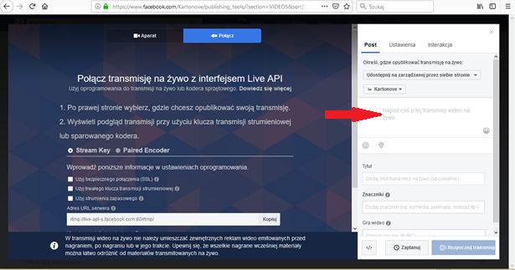
- In the TITLE field, give the event a name.
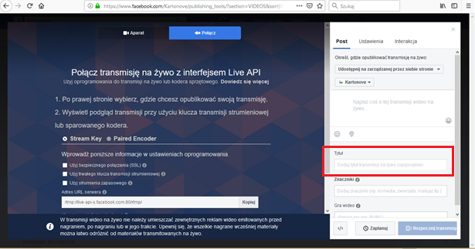
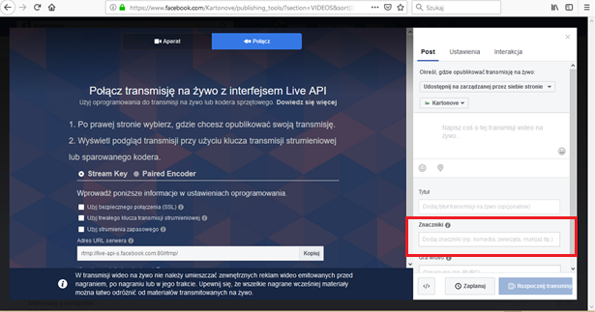
- In the TAGS field, specify the characteristic tags for the event. Thanks to this you will reach the recipients who are looking for an event through tags.

- In the SETTINGS tab, you can choose the form of transmission from those available on the list and modify their settings according to your choice thanks to the check boxes (they will appear after clicking on the black triangle on the right):
- live broadcasts,
- 360 video,
- cross posted
- game
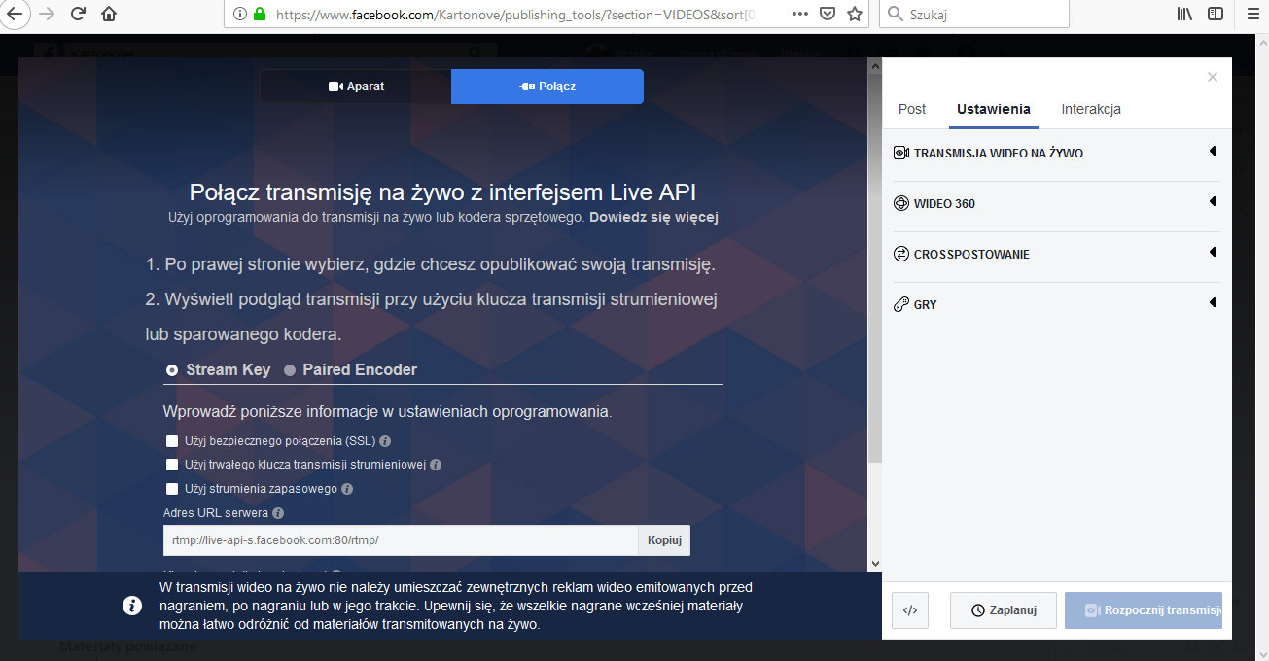

- In the LIVE VIDEO TRANSMISSION field, after expanding it, the default settings appear, such as:
- allow embedding - consent gives the possibility of the video being embedded on external sites, e.g. on a website;
- allow viewers to rewind;
- stop the broadcast after the transmission is finished.

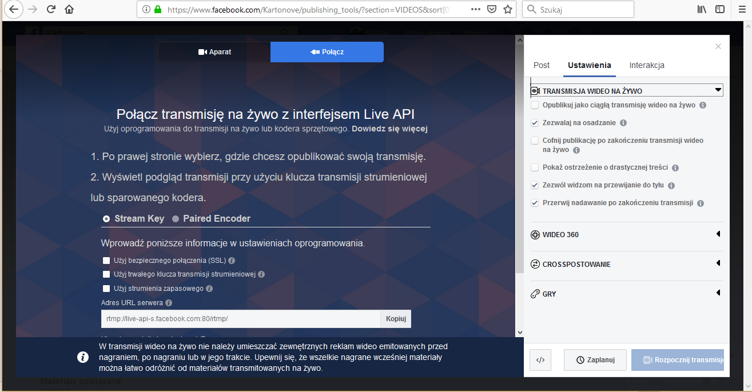

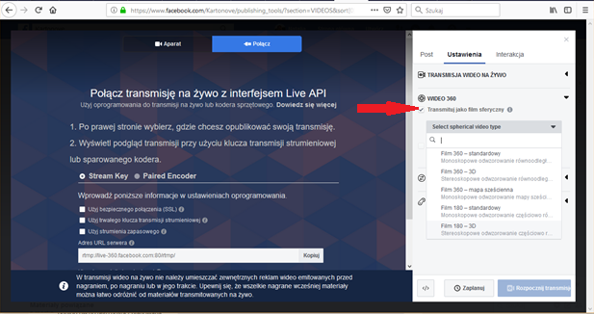
- VIDEO 360 field - here you can set the 360-image form (on standard, 3D and cubic map levels) or 180 degrees (on standard and 3D levels). You can make a selection by ticking the checkbox: transmit as an immersive video

- The CROSS-POSTING field allows you to carry out broadcasts on all fanpages to which you have permission to publish.
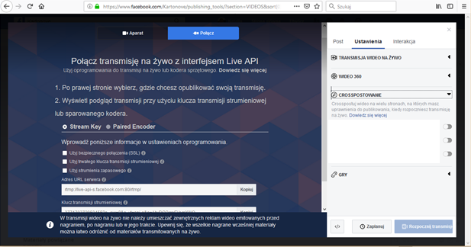

- You can schedule the transmission by clicking the schedule button, where you can set the time and date of the start of transmission.

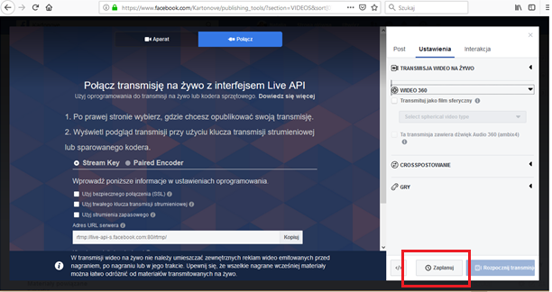

Types of live transmissions
- LIVE static or looped image.
- LIVE live with interactions – during the showing viewers comment on the image using emoticons.
- LIVE voting by comments - a solution that strongly engages the recipient. It involves conducting a survey in which viewers vote through comments or comments in the form of hashtags. Remember one participant can cast only one valid vote.
- LIVE answer search - the sender of the transmission encourages users to interact by asking questions. The application analyses each response given and in real time displays information on how many people gave the correct answers. Viewers can enter an answer several times, which significantly increases the transmission range.
- LIVE from several phones - combining transmission from two or more cameras simultaneously.
- Questions and Answers – implementation of live transmission with the help of questions and answers consists in posting selected comments in the video material provided and providing answers to them.

  - Live video on YouTube
To run a live broadcast using YouTube, it is necessary to create an account and channel. Below, in a few steps, we present the necessary tasks to implement live video.
- Select the "Creator Studio" option in the upper right of the channel. After clicking this field, a new window will appear.
- In the new window, in the left menu, select the 'Live broadcast' option. The site will automatically verify your account in terms of opinions and check your identity and whether you are a robot.
- Download and configure the encoder - a program that configures audio and video to a format that can be uploaded to YouTube. With it, you can record content using a computer, camera, microphone and other devices, and mix them at the same time by uploading to the Internet. One encoder you can use is, for example, Open Broadcaster Software - a free program recommended by YouTube.
- Insert the server URL. The URL will always be the same.
- Insert name / stream key - this changes with each transmission.
- In the BASIC INFORMATION tab add information about the event, i.e. title, description, category.
Before you start the transmission, check:
- preview in the Director's Room - test the emergency switching to the backup encoder (stop the main encoder and check if the player switches to the backup encoder)
- the correctness of all local files with the recording. Check if the size of these files is increasing.
- whether the event is available on the channel and playback pages.
- whether the event is available on mobile devices (if the transmission is also to be available on them).
Continuously monitor the image and sound quality of the transmission, synchronize the sound with the image and the volume level. Start the transmission or schedule it by setting the start and end time of the stream. Add tags, news about the video and share it via Google+ and Twitter.

- Bibliography
- http://brief.pl/dekada-facebooka-w-polsce/ on 19.12.2018.
- http://robertgrzeszczak.bio.wpia.uw.edu.pl/files/2015/03/BEZPIECZE%C5%83STWO-IMPREZ-MASOWYCH-W-%C5%9AWIETLE-PRZEPIS%C3%93W_R.-Kopczyk.pdf
- http://www.cte.org.pl/pliki/Sponsoring%20imprez%20masowych.pdf on 18.12.2018.
- http://www.strazostrow.lh.pl/prewencja/masowe.pdf
- https://fasttony.es/start/pl/zrobic-dobry-facebook-live/ on 18.12.2018.
- https://poradnik.ngo.pl/umowa-darowizny-umowa-sponsoringu-umowa-barterowa on 20.12.2018
- https://poradnikprzedsiebiorcy.pl/-live-streaming-jak-korzystac-z-niego-w-marketingu on 21.12.2018.
- https://stat.gov.pl/obszary-tematyczne/nauka-i-technika-spoleczenstwo-informacyjne/spoleczenstwo-informacyjne/spoleczenstwo-informacyjne-w-polsce-w-2017-roku,2,7.html on 21.12.2018.
- Jaworowicz P., Jaworowicz M., Event marketing in integrated marketing communication, Difin, Warsaw 2016.
- Tworzydło D., Practical PR, Newsline, Rzeszów 2017.
- Act of 20 March 2009 on the safety of mass events Dz. U. 2009 No. 62 item 504.
- Waśkowski Z., Marketing in sport - sport in marketing [in]: ed Garbarski L., Controversies around marketing in Poland - identity, ethics, future.

P. Jaworowicz, M. Jaworowicz, Event marketing in integrated marketing communication, Difin, Warszawa 2016, p. 80.
"Controversies around marketing in Poland - identity, ethics, future" ed. Lechosław Garbarski (dr Zygmunt Waśkowski – Marketing in sport - sport in marketing)
Act of 20 marca 2009 on the safety of mass events Dz. U. 2009 No. 62 item 504
http://robertgrzeszczak.bio.wpia.uw.edu.pl/files/2015/03/BEZPIECZE%C5%83STWO-IMPREZ-MASOWYCH-W-%C5%9AWIETLE-PRZEPIS%C3%93W_R.-Kopczyk.pdf
D. Tworzydło, Practical PR, Newsline, Rzeszów 2017, p. 136
http://www.cte.org.pl/pliki/Sponsoring%20imprez%20masowych.pdf on 18.12.2018
Act of 20 March 2009 on the safety of mass events Dz. U. 2009 No. 62 item 504
Act of 20 March 2009 on the safety of mass events Dz. U. 2009 No. 62 item 504.
See: Storytelling, Workshop materials.
https://poradnik.ngo.pl/umowa-darowizny-umowa-sponsoringu-umowa-barterowa on 20.12.2018
http://brief.pl/dekada-facebooka-w-polsce/ on 19.12.2018
See: Media Relations workshop
https://stat.gov.pl/obszary-tematyczne/nauka-i-technika-spoleczenstwo-informacyjne/spoleczenstwo-informacyjne/spoleczenstwo-informacyjne-w-polsce-w-2017-roku,2,7.html, on 21.12.2018
https://poradnikprzedsiebiorcy.pl/-live-streaming-jak-korzystac-z-niego-w-marketingu, on 21.12.2018
https://fasttony.es/start/pl/zrobic-dobry-facebook-live/, on 21.12.2018

